MACH-0: Fall Protection Device for Seniors

Group #5: Mars Whiteside, Alyssa Angsupanich, Casey Stott, Henry Glover

Advised by Professor Akshay Potnuru

AME 441A

Wednesday, December 11th

Abstract
A novel mechanism for hip protection was developed to lay the groundwork for an alternative form of wearable protection for the elderly. The device uses spring steel arches to increase the impulse duration, spreading the collision with the ground out over time and therefore reducing the peak impact force. A target of 20% force reduction was set based on the performance of passive foam hip pads, and this repeatedly deployable device achieves a force reduction of 50 ± 20%.
Introduction
In the past decade from 2010 to 2020, the 65 and older population in the United States saw the largest growth since 1880-1890, reaching 16.8% of the total population in 2020 with 55.8 million people [1]. With the baby boomers being born from 1946-1964, and those born in 1946 reaching 65 years old in 2011, the older population will continue to grow in the US as the baby boomers age. Falls are the largest cause of death among this increasing 65 and older population, contributing to 58.1% of all deaths in 2020, beating the second highest cause of death, heart disease, which contributed to 22.2% of deaths [2]. Additionally, even if a fall is non-fatal, falling can leave lasting psychological trauma. This can create a cycle with the elderly where the first fall creates a fear of falling, causing them to reduce physical activity which decreases their functionality and can contribute to subsequent falls [3]. Falls can also cause non-fatal injuries with lengthy recovery timelines or lasting physical damage. With falls being a health concern to an increasing portion of the population, this project aims to prove the viability of a novel method of reducing the damage to the body after a fall.
Hip injuries are a leading fall-related injury suffered by elderly persons, and very commonly require surgery, with its own rehabilitation period of up to 1 year, to resolve. Hip fractures are also involved in approximately 1 in 3 fall-related deaths [2]. Therefore, this project looks to lay the groundwork for a novel hip protection device that utilizes a mechanical method of absorbing or redistributing force as an alternative to existing solutions.
The fall protection devices on the market currently fall into two primary categories, that of passive foam pads, and that of deployable airbag devices. Airbag devices offer a small, deployable fall protection option, but they require a replacement gas cannister after each deployment, and are priced significantly higher than passive options at upwards of $750. Gas cannister refills cost an additional $60-$70 [4]. Although it is early in the research and development cycle to tell, it seems likely that an active mechanical solution with proven functionality and repeatability could compete in the market.
Existing research on passive wearable hip pads provide a benchmark for impact reduction in order to be a viable solution. From Derler et. al., which tested a variety of wearable hip pads currently on the market, it was determined that an impact force reduction of 20% would be comparable to the current state of protection technology [5].
As a deployable solution, this device would require a fall detection mechanism. From existing literature on the topic, both threshold-based and machine learning algorithms are viable options, but outside the scope of this project. In the case of Tamura et al. whose fall detection system utilized a threshold-based algorithm, one’s movement would be considered a fall if their acceleration fell below ±3 m/s² and their angular acceleration surpassed 0.52 rad/s. This particular set of thresholds was defined under the assumption that one’s falling would be characteristic of free fall. Although this occasionally resulted in false fall detections when a person was running, jumping, or took a defensive fall position by bending their knees, their threshold-based algorithm maintained an accuracy of 93% [6]. Machine learning algorithms, for example using the convolutional neural network method illustrated in Santos et al., which in that paper resulted in both accuracy and specificity upwards of 99% [7]. A threshold detection device would be relatively inexpensive and sufficiently accurate, while a machine learning-based device would be more resource intensive but provide improved detection. Although neither was explored in the context of this project, the viability of detecting falls to deploy the device is well illustrated in the literature.
Design
With the goal of creating an entirely reusable, novel, and deployable mechanical alternative to fall protection devices currently on the market – notably airbags and passive foam pads – inspiration was taken from the nostalgic children’s toy, the Phlat Ball, seen in Figure 1.

Figure 1. Phlat ball composed of curved panels in disk configuration (top) and ball configuration (bottom).
The foundation for the design revolved around utilizing 1075 spring steel leaves compressing to absorb and disperse the forces experienced upon impact. Following numerous iterations, the finalized design featured a set of three floating-end, .025” thick leaves arranged in a hexagonal pattern with the ends being constrained to horizontal linear motion by way of slots. A 3D printed baseplate with these slots was constructed to house all the components while a set of pins and water-jetted retaining brackets hold the spring steel leaves in the slots. A buckling rod release mechanism was then designed to hold the spring steel leaves in a flat, stored state while also providing the ability for a solenoid to actuate and deploy the system. In the stored state the buckling mechanism is held by two pins located just past the unstable equilibrium point – the point at which both buckling arms are in line with each other and the steel spring leaves are at their most compressed. The solenoid, sitting just behind the two pins, may then actuate to push the buckling mechanism past the equilibrium point, allowing the spring steel plates to freely articulate and expand into their fully deployed state. A diagram depicting this sequence of events is seen in Figure 2.
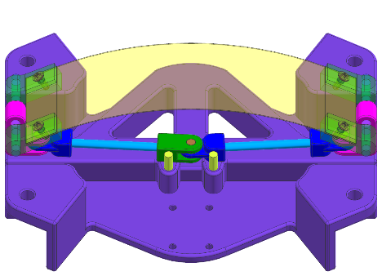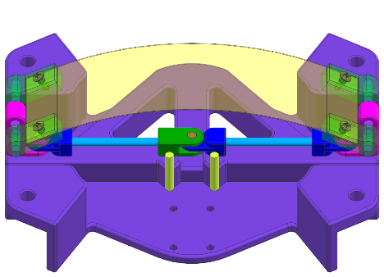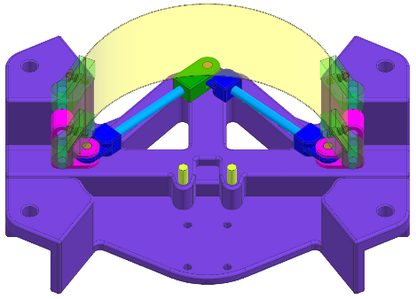
Figure 2. Release mechanism stable in initial position (left), pushed through central unstable equilibrium point (middle) and to freely movable configuration (right) whilst the shown spring steel leaf expands into deployed state.
The full assembly of the final design in its stored and deployed state may be seen below in Figure 3 while the exploded view may be found in Appendix i.
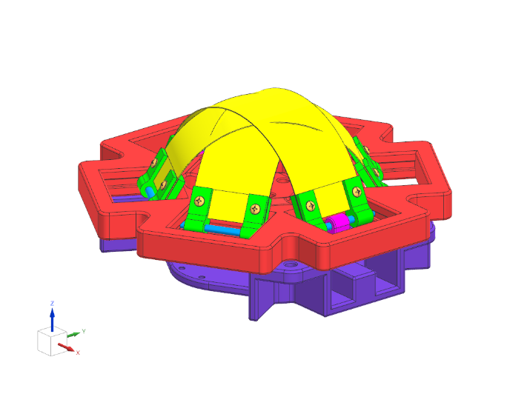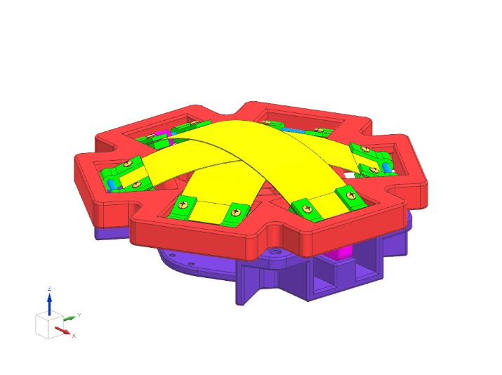
Figure 3. Full assembly of final design in the stored, flat state (left) and the deployed state (right).
The fully assembled physical model in its deployed state is shown in Figure 4 below. The buckling rod release mechanism is installed and functional on this final model of the device.

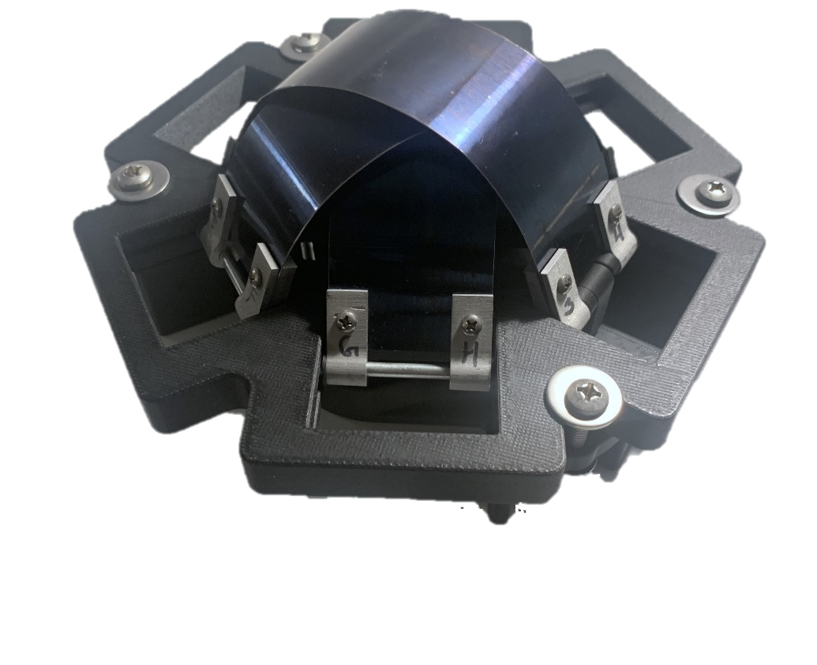
Figure 4. Finalized proof of concept hip protection device, with the spring steel leaves extended in the deployed state.

Theory
Provided that the final mechanism features a stack of three spring steel leaves, one may treat each individual spring as a cantilever beam mirrored about its fixed support and replaced by its equivalent reaction force. This also operates under the assumption that friction forces resisting the expansion of each spring leaf due to the pins sliding along the slots in the baseplate are negligible. To calculate the force required to displace the spring steel leaf as dictated by the mechanism’s design, one may simplify the system even further by analyzing half of each leaf as a cantilevered beam. This simplification of equating half of each spring steel leaf to a cantilevered beam is seen in Figure 5.
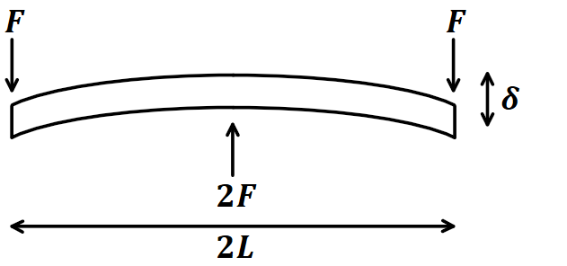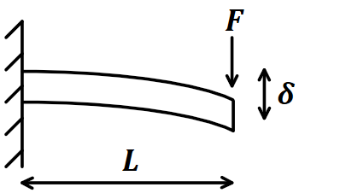
Figure 5. Beam bending diagram of a leaf spring simplified as a mirrored cantilevered beam (left) with the half system equating to a simple cantilevered beam. $F$ represents the force applied to either end while $L$ is the average projected half-length and $δ$ is the vertical displacement.
With this simplification of the half-system as a cantilevered beam, the maximum displacement, $δ$, may be calculated from Equation 1 below
 | $$δ=\frac{FL^{3}}{3EI}$$ | 1

where $F$ is the applied force to the cantilever beam, $L$ is the average projected half-length, $E$ is the Young’s modulus, and $I$ is the area moment of inertia of the beam’s cross section [8].
With each spring steel leaf being 2” (50.80 mm) wide and .025” (.635 mm) thick, the area moment of inertia was calculated to be 1.08 mm³. Furthermore, as the design utilizes 1075 spring steel the Youngs modulus is found to be 200 GPa [8]. As the design of the fall protection device allows for a maximum deflection, $δ$, of 30.48 mm between the deployed and stored states and includes an average half projected length, $L$, of 80.11 mm, solving for the applied force in Equation 1 yields a value of 38.56 N per each half of each leaf. This combines to find the force required to fully compress all three spring steel leaves is approximately 231.35 N. Upon testing where the fall protection device was compressed on top of a load cell with the final force being recorded, this theoretical force was validated as the force required to compress the device was 52 ± 2 lbf, or 231 ± 9 N.

Experimental Setups
To investigate the impact force absorption properties of 1075 spring steel, a comprehensive test was conducted using the Instron Dynatup 9250 HV impact drop tower. Dynamic force measurements were taken for spring steel samples with thicknesses of .010”, .015” and .025”. The testing jig, fabricated from aluminum and depicted in Figure 6, was designed with corner standoffs to eliminate unintended force application on the spring steel samples. Additionally, the jig incorporated pins to securely maintain the component’s angle, ensuring consistent sample placement.
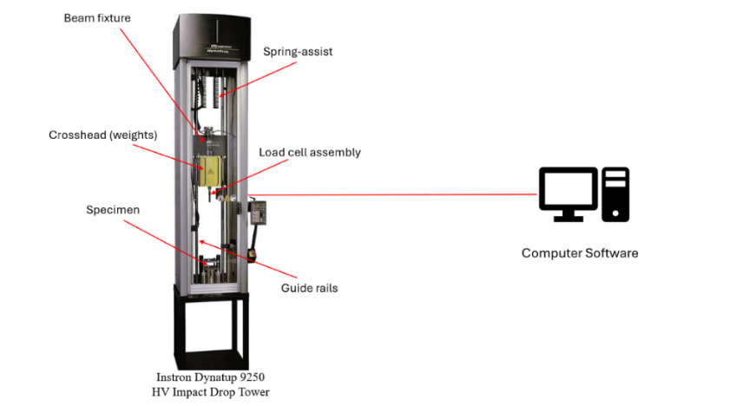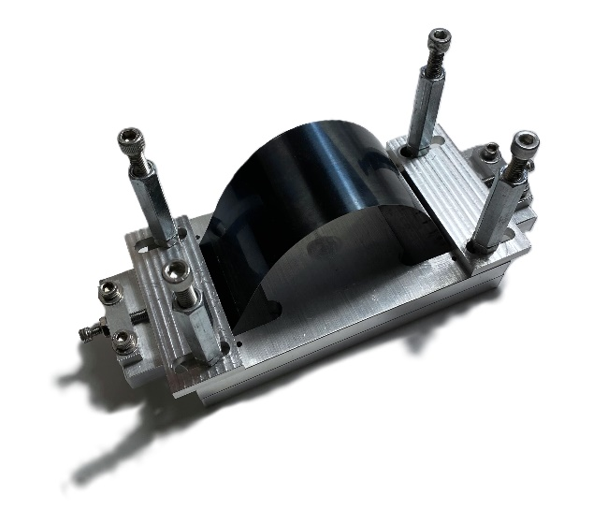
Figure 6. Instron Drop tower diagram, left, and aluminum testing jig used to hold spring steel arches of varying thicknesses and lengths.
Initial tests conducted using the drop tower had a target impact energy of 49.1 J. However, some samples experienced a bottoming-out effect, where the spring steel fully compressed, causing the measured impact to reflect contact with the aluminum base of the jig rather than the spring steel’s response. To resolve the issues, subsequent tests were conducted with a reduced target impact energy of 10 J, ensuring reliable data by preventing bottoming-out effects. The data was captured using Excel and subsequently interpreted using MATLAB. The processed data is presented in the results and discussion section of the report.
The spring steel samples were also subjected to a constant load using a hydraulic press to characterize the material under steady loading conditions, as shown in Figure 7. Testing from both the impact drop tower and the hydraulic press revealed that tempered 1075 spring steel with a thickness of .025” offered the optimal combination of energy absorption and force dissipation.
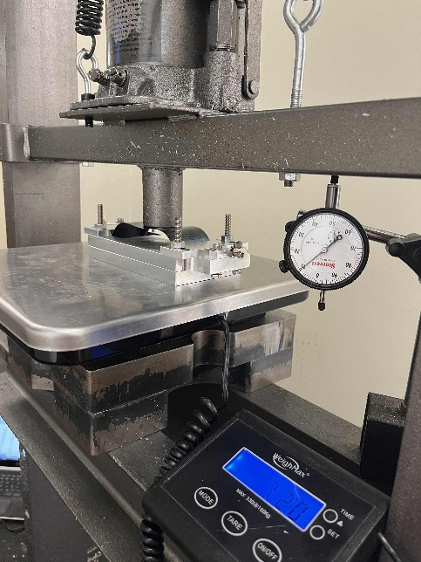
Figure 7. Spring steel arch specimen under load by shop press, with displacement gauge and scale for displacement and force measurements respectively.
The final prototype incorporated .025” spring steel into its design. To conduct force and impact related testing, an inverted pendulum jig was constructed to simulate the dynamics of an unprotected fall to the side. The jig facilitated a guided pendulum motion with a fixed one degree of freedom rotation, constructed by a hinge at the base of the setup. The pendulum was built of 2x4 wood planks secured with wood screws, a door hinge, and duct tape. This allowed for a controlled motion constrained to a single plane by a steel testing frame. The setup allowed for a maximum angular displacement of 90˚, as show in Figure 8 below. The dynamics of the pendulum motions were recorded using the OptiTrack 120 X Prime camera system at 1000 Hz to measure angular position, velocity, and rotation. The camera system recorded at 1000 FPS.

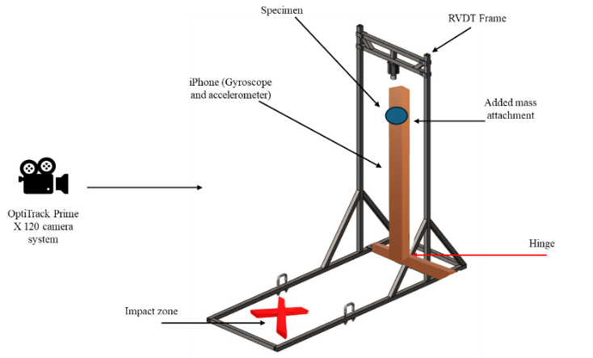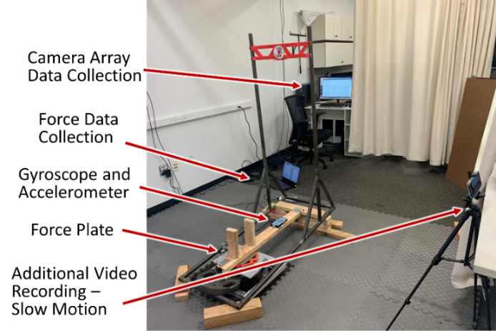
Figure 8. Diagram of testing setup, left, and physical testing setup as realized in the lab environment.
The prototyped test specimen is shown below in Figure 9, showing the final design of the component used in testing. The prototype underwent several iterations to optimize its functionality, durability, and compatibility with the testing apparatus.
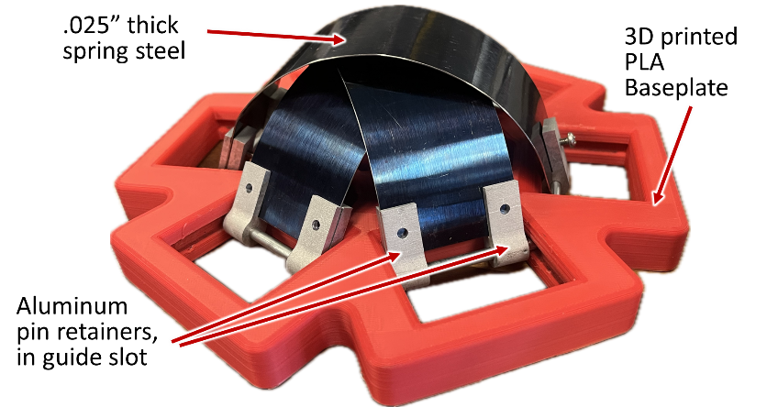
Figure 9. Test specimen, featuring a 3D printed baseplate and guiding slots within which the spring steel leaves moved.
A force plate was initially introduced to measure force, as the impact to the wearer is ultimately what must be attenuated to prevent injury. However, due to the force plate’s insufficient sampling rate, acceleration data from the OptiTrack 120 X Prime was used for further analysis instead. From Newton’s second law, acceleration is proportional to force, so by examining the change in magnitude of the pendulum’s rebound between trials with and without the device, the percentage of force reduction can be determined. Due to the sampling rate issues, the force plate was omitted from the final setup. The OptiTrack setup produced data measuring the linear and rotational positions and velocities of the pendulum by using a rigid body inferred tracker to capture the motion of the system. This approach offered a high level of precision, with a 3D accuracy of +/- 0.1 mm.

Results and Discussion
Constant Loading Hydraulic Press
An illustrative force versus displacement graph is shown below in Figure 10 of a 7.875” long arch.
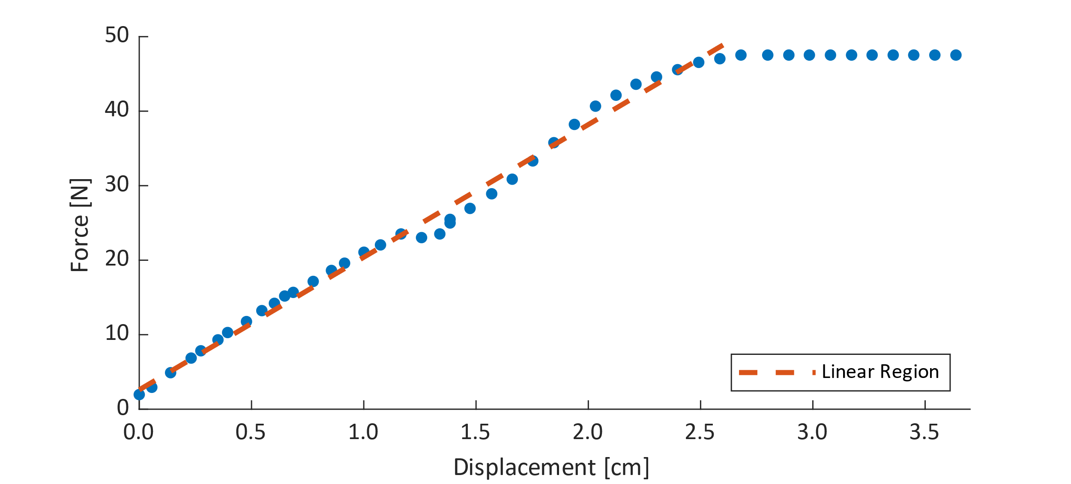
Figure 10. Force versus displacement curve of a 7.875” long 0.010” thick arch displaying linear force region observed in all trials. Effective spring constant values refer to slope of the linear region.
The force versus displacement curves resembled the shape of the stress versus strain curves of a standard wishbone steel sample, such that a linear region exists and Hooke’s Law can be applied. The arched shape of the spring steel still allowed standard approximations to be applied, such that the arches can be treated as a linear spring before the force plateau. An effective spring constant was calculated as the slope of the linear regression applied to the linear regions, allowing comparisons to be drawn between the spring steel force outputs of various leaf thicknesses. Table 1 below compares the effective spring constants of 6” arches with thickness increasing by .005”.
Table 1. Effective Spring Constants of 6” Arches of Varying Thicknesses
Thickness [in] | .010 | .015 | .020
Effective Spring Constant [N/cm] | $$57±4$$ | $$200±6$$ | $$262±8$$

The constant loading test showed a positive relationship between spring steel thickness and effective spring constants, meaning the max force of the system can be tuned simply by changing the thickness of the spring leaves without changing the geometry of the baseplate or release mechanism. Increasing the maximum force allows the device to sustain higher impact forces without plastic deformation, allowing the device to be scaled to real world forces after development of the design.
Vertical Drop Tower
The constant loading condition was helpful in determining force behavior of the arches, but as this device’s aim is fall protection, further testing was done with a vertical drop tower to characterize spring arch behavior under impact. Although the static behavior was scalable and had a simple governing equation, the arch shape could have unforeseen dynamic effects, or behave differently with the shock of impact than under a steadily increasing load. A comparison of different thicknesses of spring steel subject to 10 J of impact energy is shown in Figure 11 below.
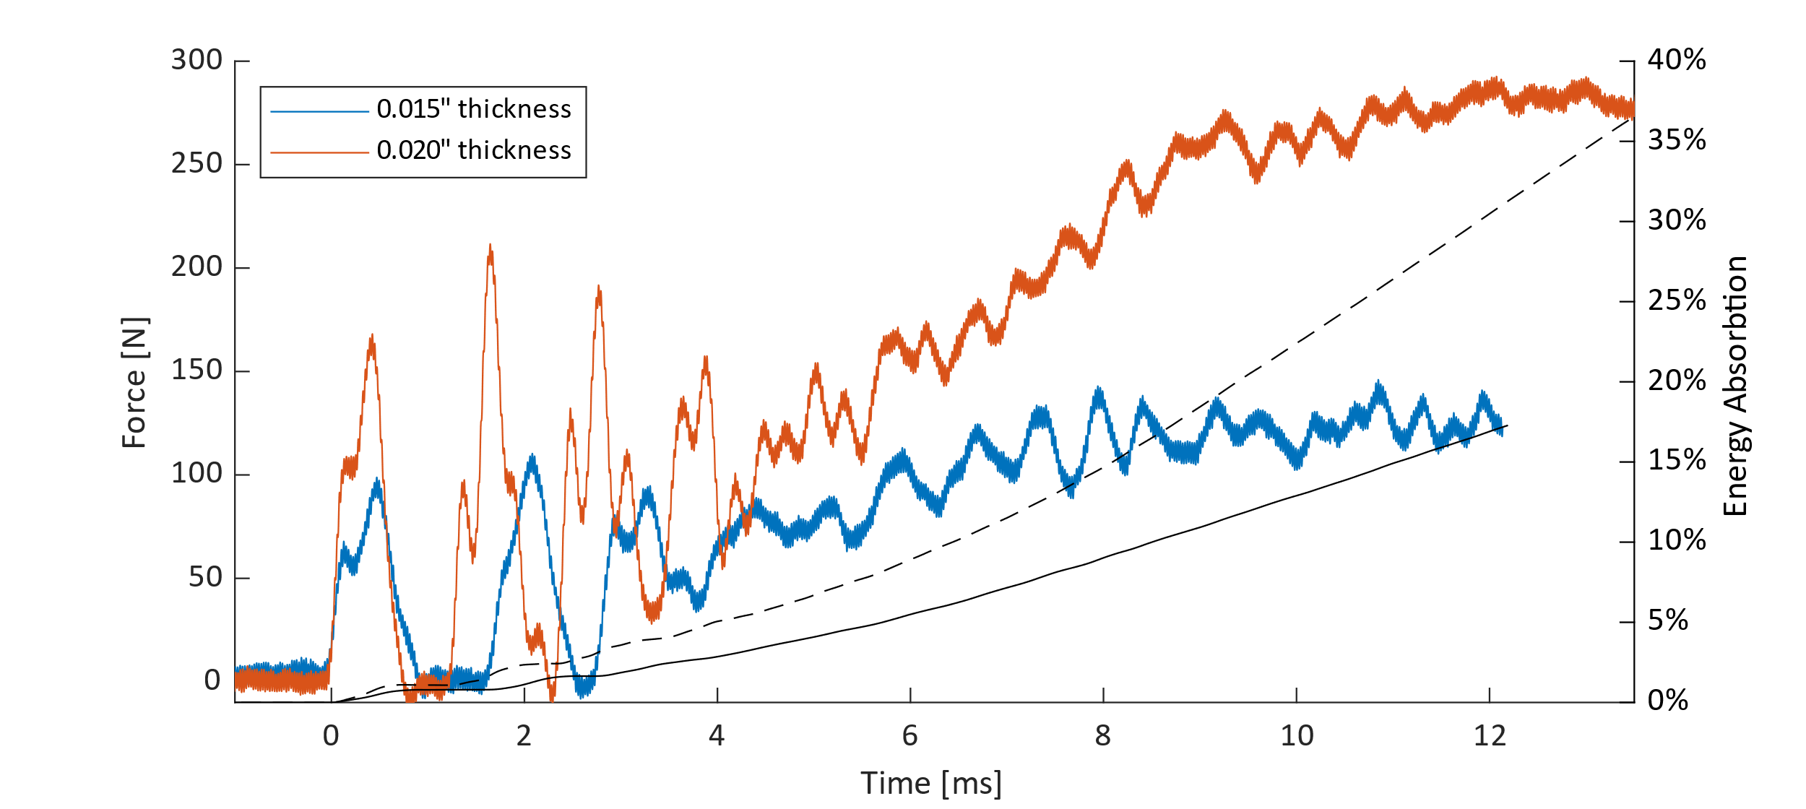
Figure 11. Illustrative force curves of .015” and .020” thick arches under 10 J of impact energy. While unexpected oscillations occurred, the max force continued to positively correlate with leaf thickness. Energy absorption also positively correlated with leaf thickness, indicating viability of scaling device loads with simple leaf swapping.
The force curves exhibited a period of oscillation before the upward trend. While the oscillation period was unexpected, the max force achieved increased with thickness, meaning the arch geometry did not adversely affect the predicted positive correlation between thickness and energy absorption. This confirmed that under impact, the higher spring constant of the thicker arches connected to energy absorption of the arch. This fully confirmed the ability to scale the device’s sustained impact loads by varying spring steel leaf thickness, allowing the spring steel to be chosen within the bounds of in-house manufacturability.
The data obtained from the drop tower records only the small time period immediately after impact. The oscillations during this time period, although large in appearance in Figure 11, are not of a magnitude or scale concerning to the scope of this project. To characterize the larger scale bouncing, which is more relevant to possible rebound effects on the end user, the tip of the impact head was tracked from video over the second and a half following impact, shown in Figure 12. below.
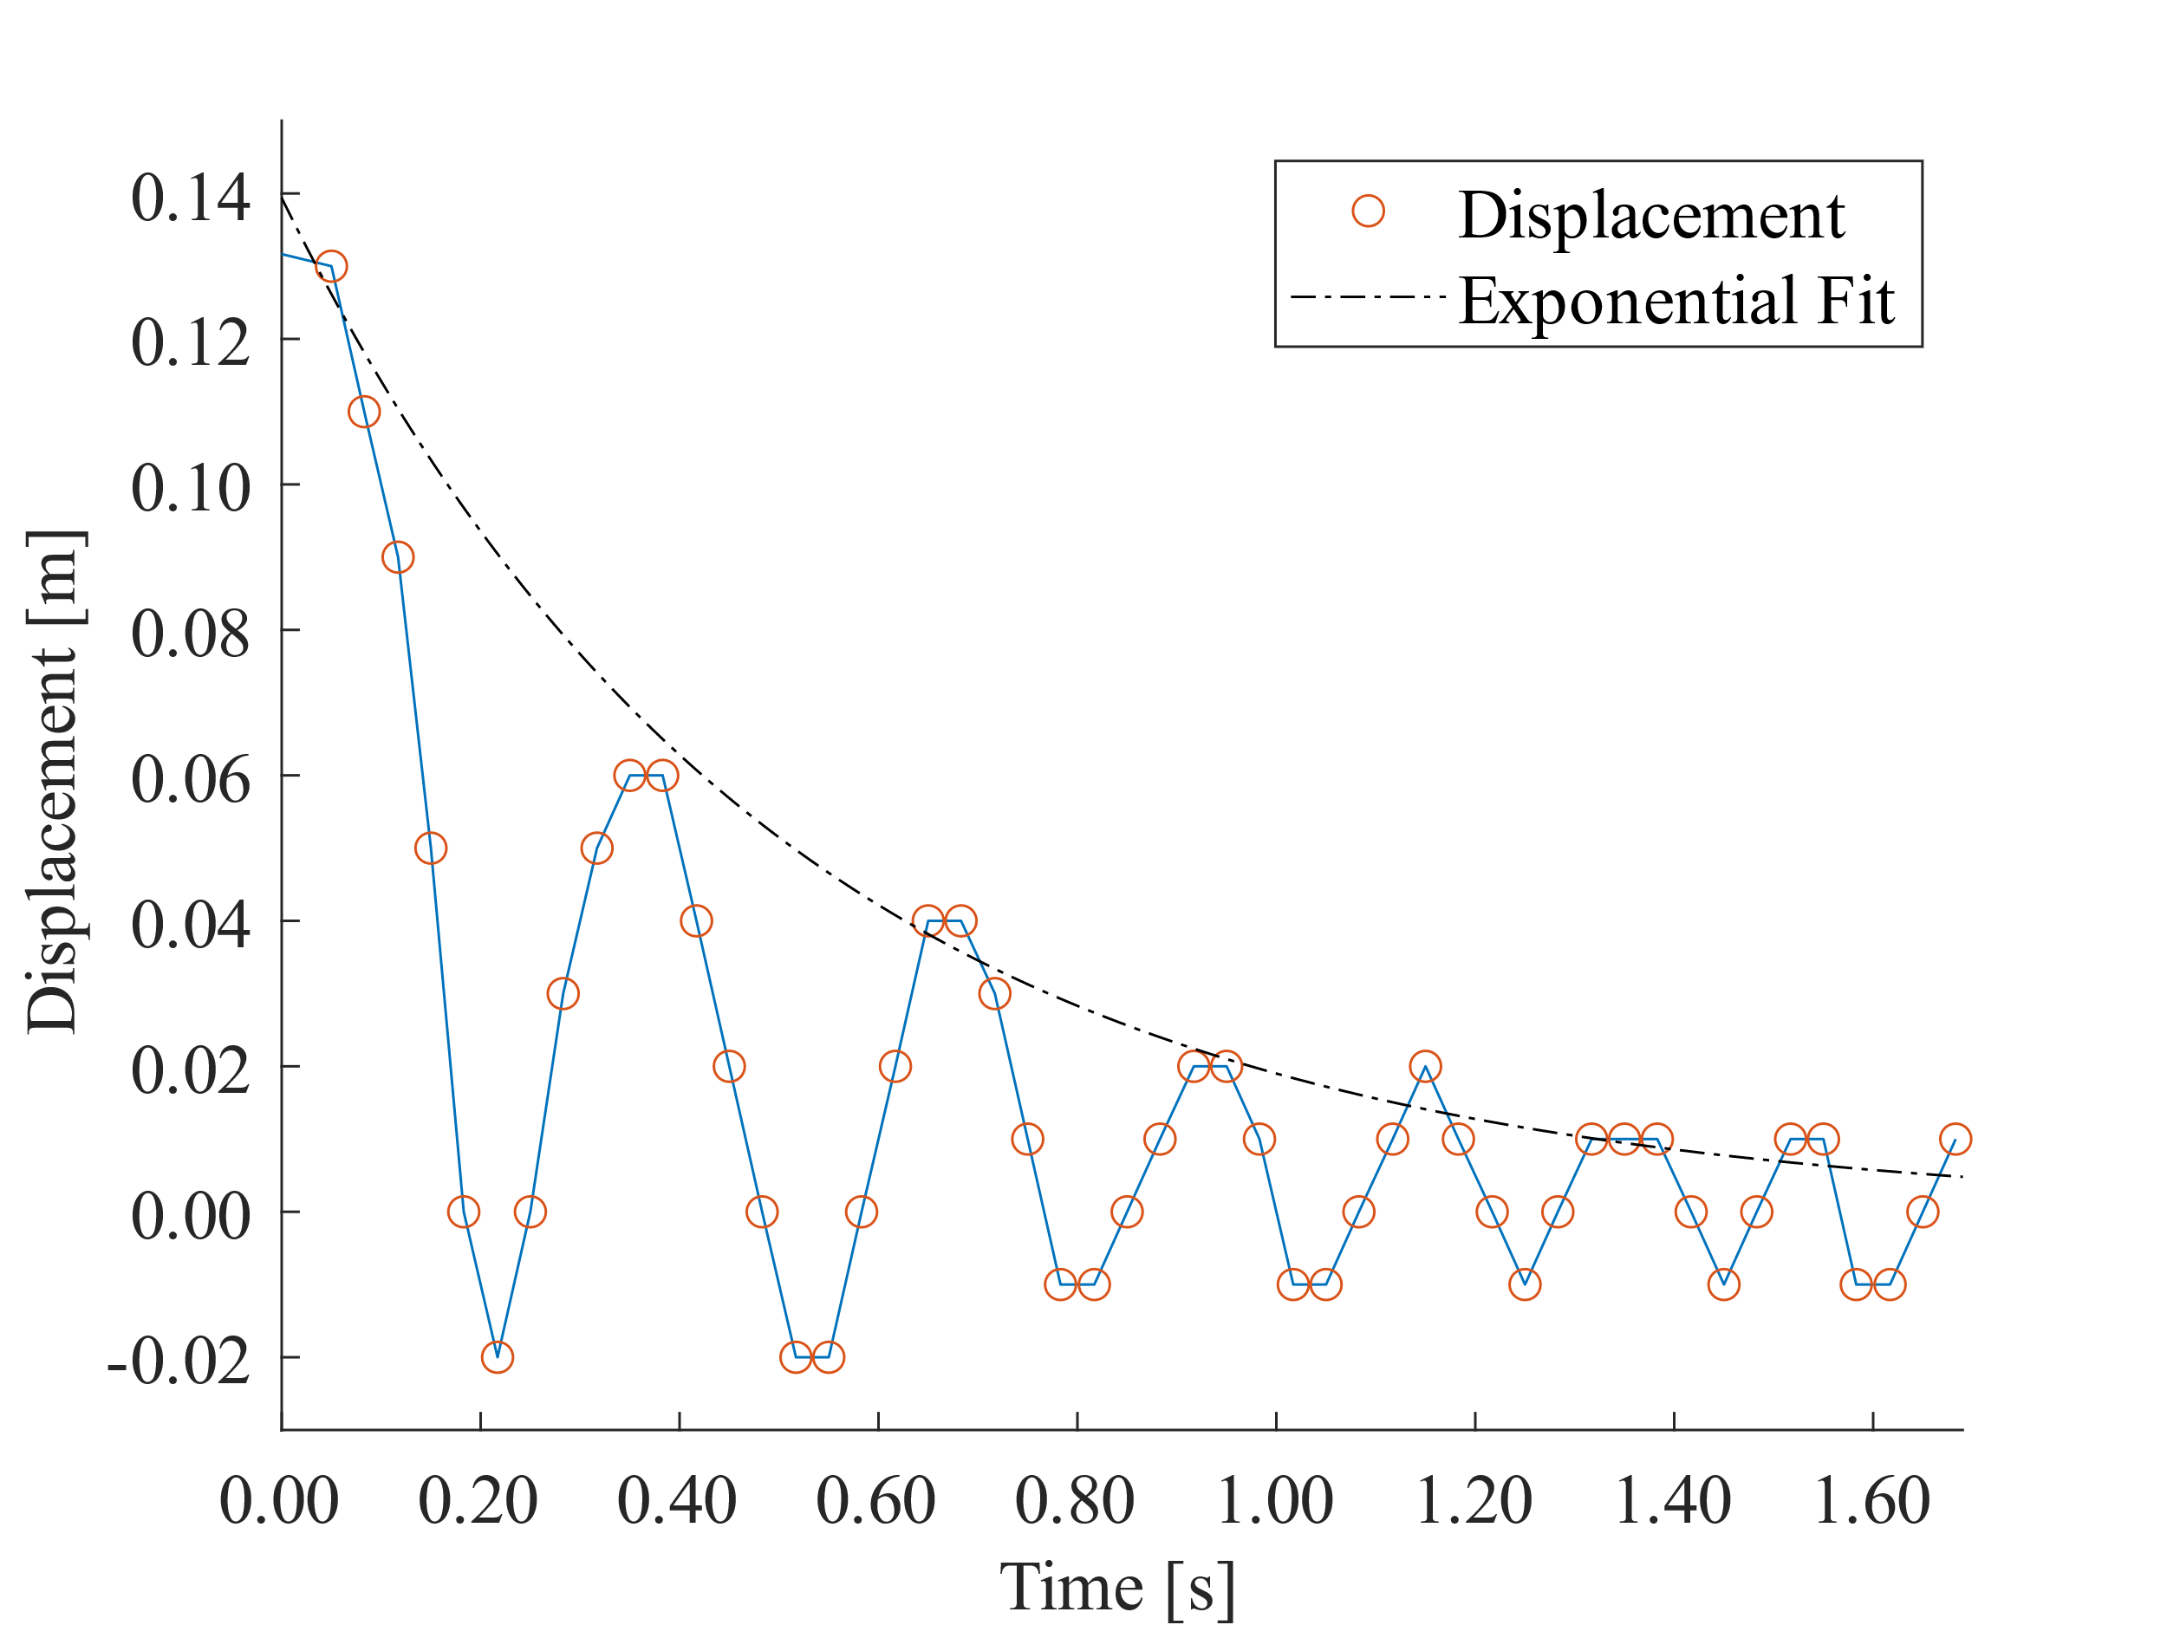
Figure 12. Video tracked position of drop tower impact head, demonstrating decaying rebound bounces, with an exponential fit to illustrate the decay pattern.
Pendulum Drop Test
The dynamic response of the spring-equipped and non-spring equipped samples were evaluated during an inverted pendulum test, simulating realistic travel and impact angle of a sideways fall onto the hip. Representative plots of angular rotation, velocity, and acceleration are show in Figure 13 below.
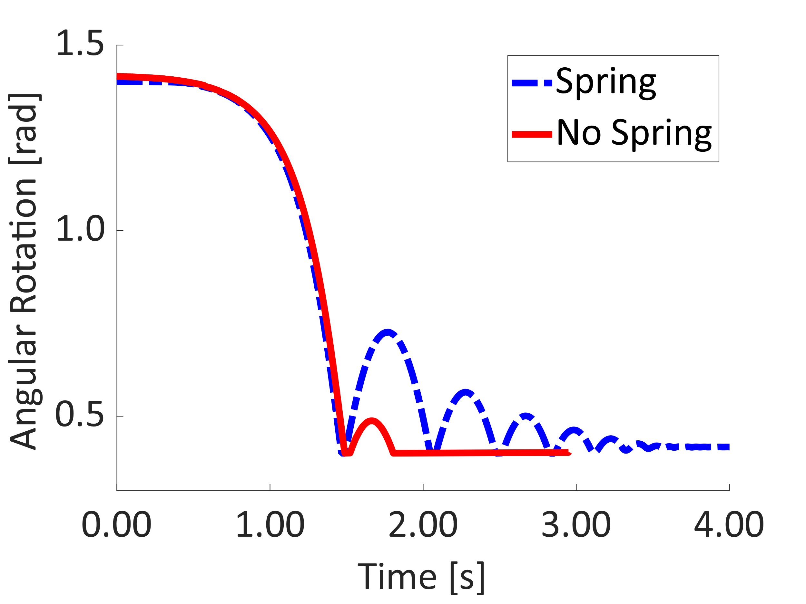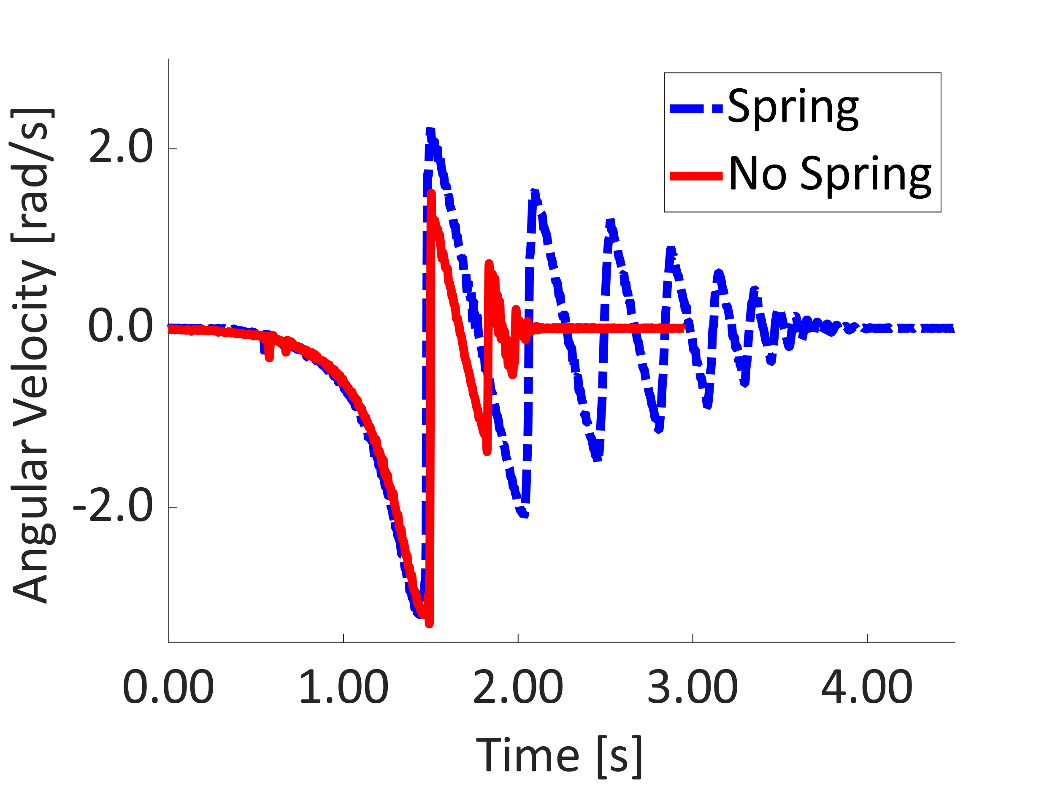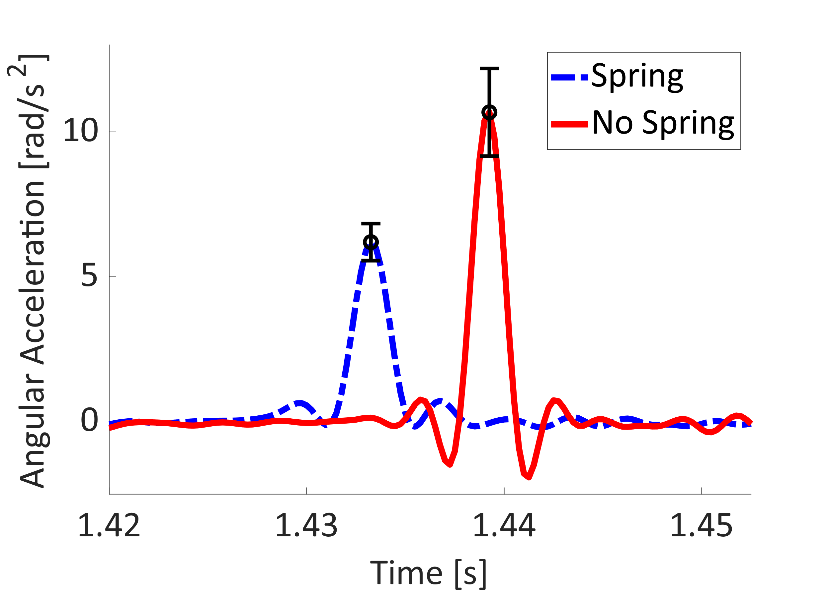
Figure 13. On the top left, the angular rotation of the pendulum before and after impact. The spring trial experienced five rebounds opposed to the no spring trial’s one. On the top right, the angular velocity depicting the spring trial’s longer time until steady state and larger velocities after rebounding. The bottom graph depicts an illustrative comparison of acceleration peaks, with the spring trial exhibiting a lower peak acceleration than the no spring. The acceleration graph was scaled to match averaged values among trials.
The angular rotation versus time plot in the top left of Figure 13 displayed differences in number of rebounds and max rebound height between the spring and no spring trials. The spring-equipped setup demonstrated a greater max angular rotation of 0.726 radians after impact, meaning it rebounded to a higher height than the non-spring setup, which showed a 0.487 radian rotation post impact. The spring trial also sustained oscillations for a longer duration, shown in the number of rebounds and time until rest. The higher rebound height and increased number of rebounds meant the spring was storing and redirecting the impact energy.
The spring’s ability to transfer and store energy allowed the system to take longer time until coming to rest, or reaching steady state, when compared with the no-spring system. The spring took 3.75s until steady state while the non-spring system reached a steady state in 1.81s. The increased oscillation time meant the spring system allowed the impact energy to be dissipated over a longer period of time, decreasing the rate at which energy was absorbed into the pendulum, the stand in for the user’s hip.
The angular velocity plot in the top right of Figure 13 similar shows extended time until steady state for the spring system. The plot also showed the same -3.82 rad/s velocity before impact for both the spring and non-spring systems, showing that the variation in results was not from any differences in the starting energy of the trials. The larger peak velocity of the spring system further corroborated the spring’s ability to absorb and redirect energy.
The spring system’s force reduction capabilities can be quantified by comparing the peak angular accelerations of the spring and no spring systems. The bottom of Figure 13 displays an illustrative angular acceleration plot, visually demonstrating the reduction in acceleration from the addition of the spring steel device. The spring’s capability of increasing impact time can be seen by comparing the widths of the acceleration peaks, where the no-spring peak had a narrower base than the with-spring peak. The increase in impact duration time explains the reduction in max force, and therefore acceleration of the spring system. Table 2 below shows a quantitative summary of the acceleration values displayed in the graph.
Table 2. Comparison of Max Angular Acceleration for Spring vs. No Spring System
No Spring Peak Acceleration  [rad/s²] | Spring Peak Acceleration  [rad/s²] | Acceleration Reduction  [%]
$$11±2$$ | $$6±1$$ | $$50±20\%$$

The observed difference in angular acceleration demonstrated the damping and energy distributing effects of the spring-equipped system. The $50±20\%$ angular acceleration reduction meant the device exceeded the 20% force reduction target, proving the viability of spring steel arches in a mechanical fall protection device. The previous tests showing spring leaf thickness can be increased to scale the device’s max force capacity means the $50±20\%$ force reduction can be applied despite the difference between the pendulum testing weight and that of a real human.

Conclusion
This project ultimately achieves the goal of demonstrating a proof of concept for a novel mechanical fall protection solution. The current state of the device has some downsides, but future work can be conducted to optimize the important factors. For example, the current testing assembly is built to attach to a specific drop-testing setup and not a human, and is therefore quite heavy. However, the basis of the design, the spring steel leaves, are lightweight and effective, reducing the impact force by $50±20\%$, and surpassing the target $20\%$ reduction benchmark. Therefore, there is nothing in the nature of the concept that at this juncture prevents the development of a lightweight deployable mechanism.
From the basis of the device outlined in this report, future work on a personal protective device would follow. The spring steel arch mechanism is unlike other fall protection devices in the literature, and worth exploring. The resulting device could be calibrated for different body weights by modulating the thickness of the steel. It also would require no compressed gasses like airbag solutions, and could have form factor advantages over passive hip pads.

Works Cited
[1] U.S. Census Bureau, Z. Caplan, and M. Rabe, “The Older Population: 2020,” May 2023.
[2] J. A. Stevens and R. A. Rudd, “Circumstances and Contributing Causes of Fall Deaths among Persons Aged 65 and Older: United States, 2010,” J. Am. Geriatr. Soc., vol. 62, no. 3, pp. 470–475, Mar. 2014, doi: 10.1111/jgs.12702.
[3] R. Patil, K. Uusi-Rasi, P. Kannus, S. Karinkanta, and H. Sievänen, “Concern about falling in older women with a history of falls: associations with health, functional ability, physical activity and quality of life,” Gerontology, vol. 60, no. 1, pp. 22–30, 2014, doi: 10.1159/000354335.
[4] “Hip’Guard airbag belt,” Hip Guard. Accessed: Dec. 11, 2024. [Online]. Available: https://hipguard.eu/en/produit/shop-hipguard-airbag-belt/
[5] S. Derler, A. B. Spierings, and K.-U. Schmitt, “Anatomical hip model for the mechanical testing of hip protectors,” Med. Eng. Phys., vol. 27, no. 6, pp. 475–485, Jul. 2005, doi: 10.1016/j.medengphy.2005.02.001.
[6] T. Tamura, T. Yoshimura, M. Sekine, M. Uchida, and O. Tanaka, “A Wearable Airbag to Prevent Fall Injuries,” IEEE Trans. Inf. Technol. Biomed., vol. 13, no. 6, pp. 910–914, Nov. 2009, doi: 10.1109/TITB.2009.2033673.
[7] G. L. Santos, P. T. Endo, K. H. de C. Monteiro, E. da S. Rocha, I. Silva, and T. Lynn, “Accelerometer-Based Human Fall Detection Using Convolutional Neural Networks,” Sensors, vol. 19, no. 7, p. 1644, Apr. 2019, doi: 10.3390/s19071644.
[8] F. Beer, E. Johnston, J. DeWolf, and D. Mazurek, Mechanics of Materials, 8th ed. McGraw Hill, 2019. Accessed: Sep. 06, 2024. [Online]. Available: https://www.mheducation.com/highered/product/mechanics-materials-beer-johnston/M9781260113273.html

Appendices
- Exploded View
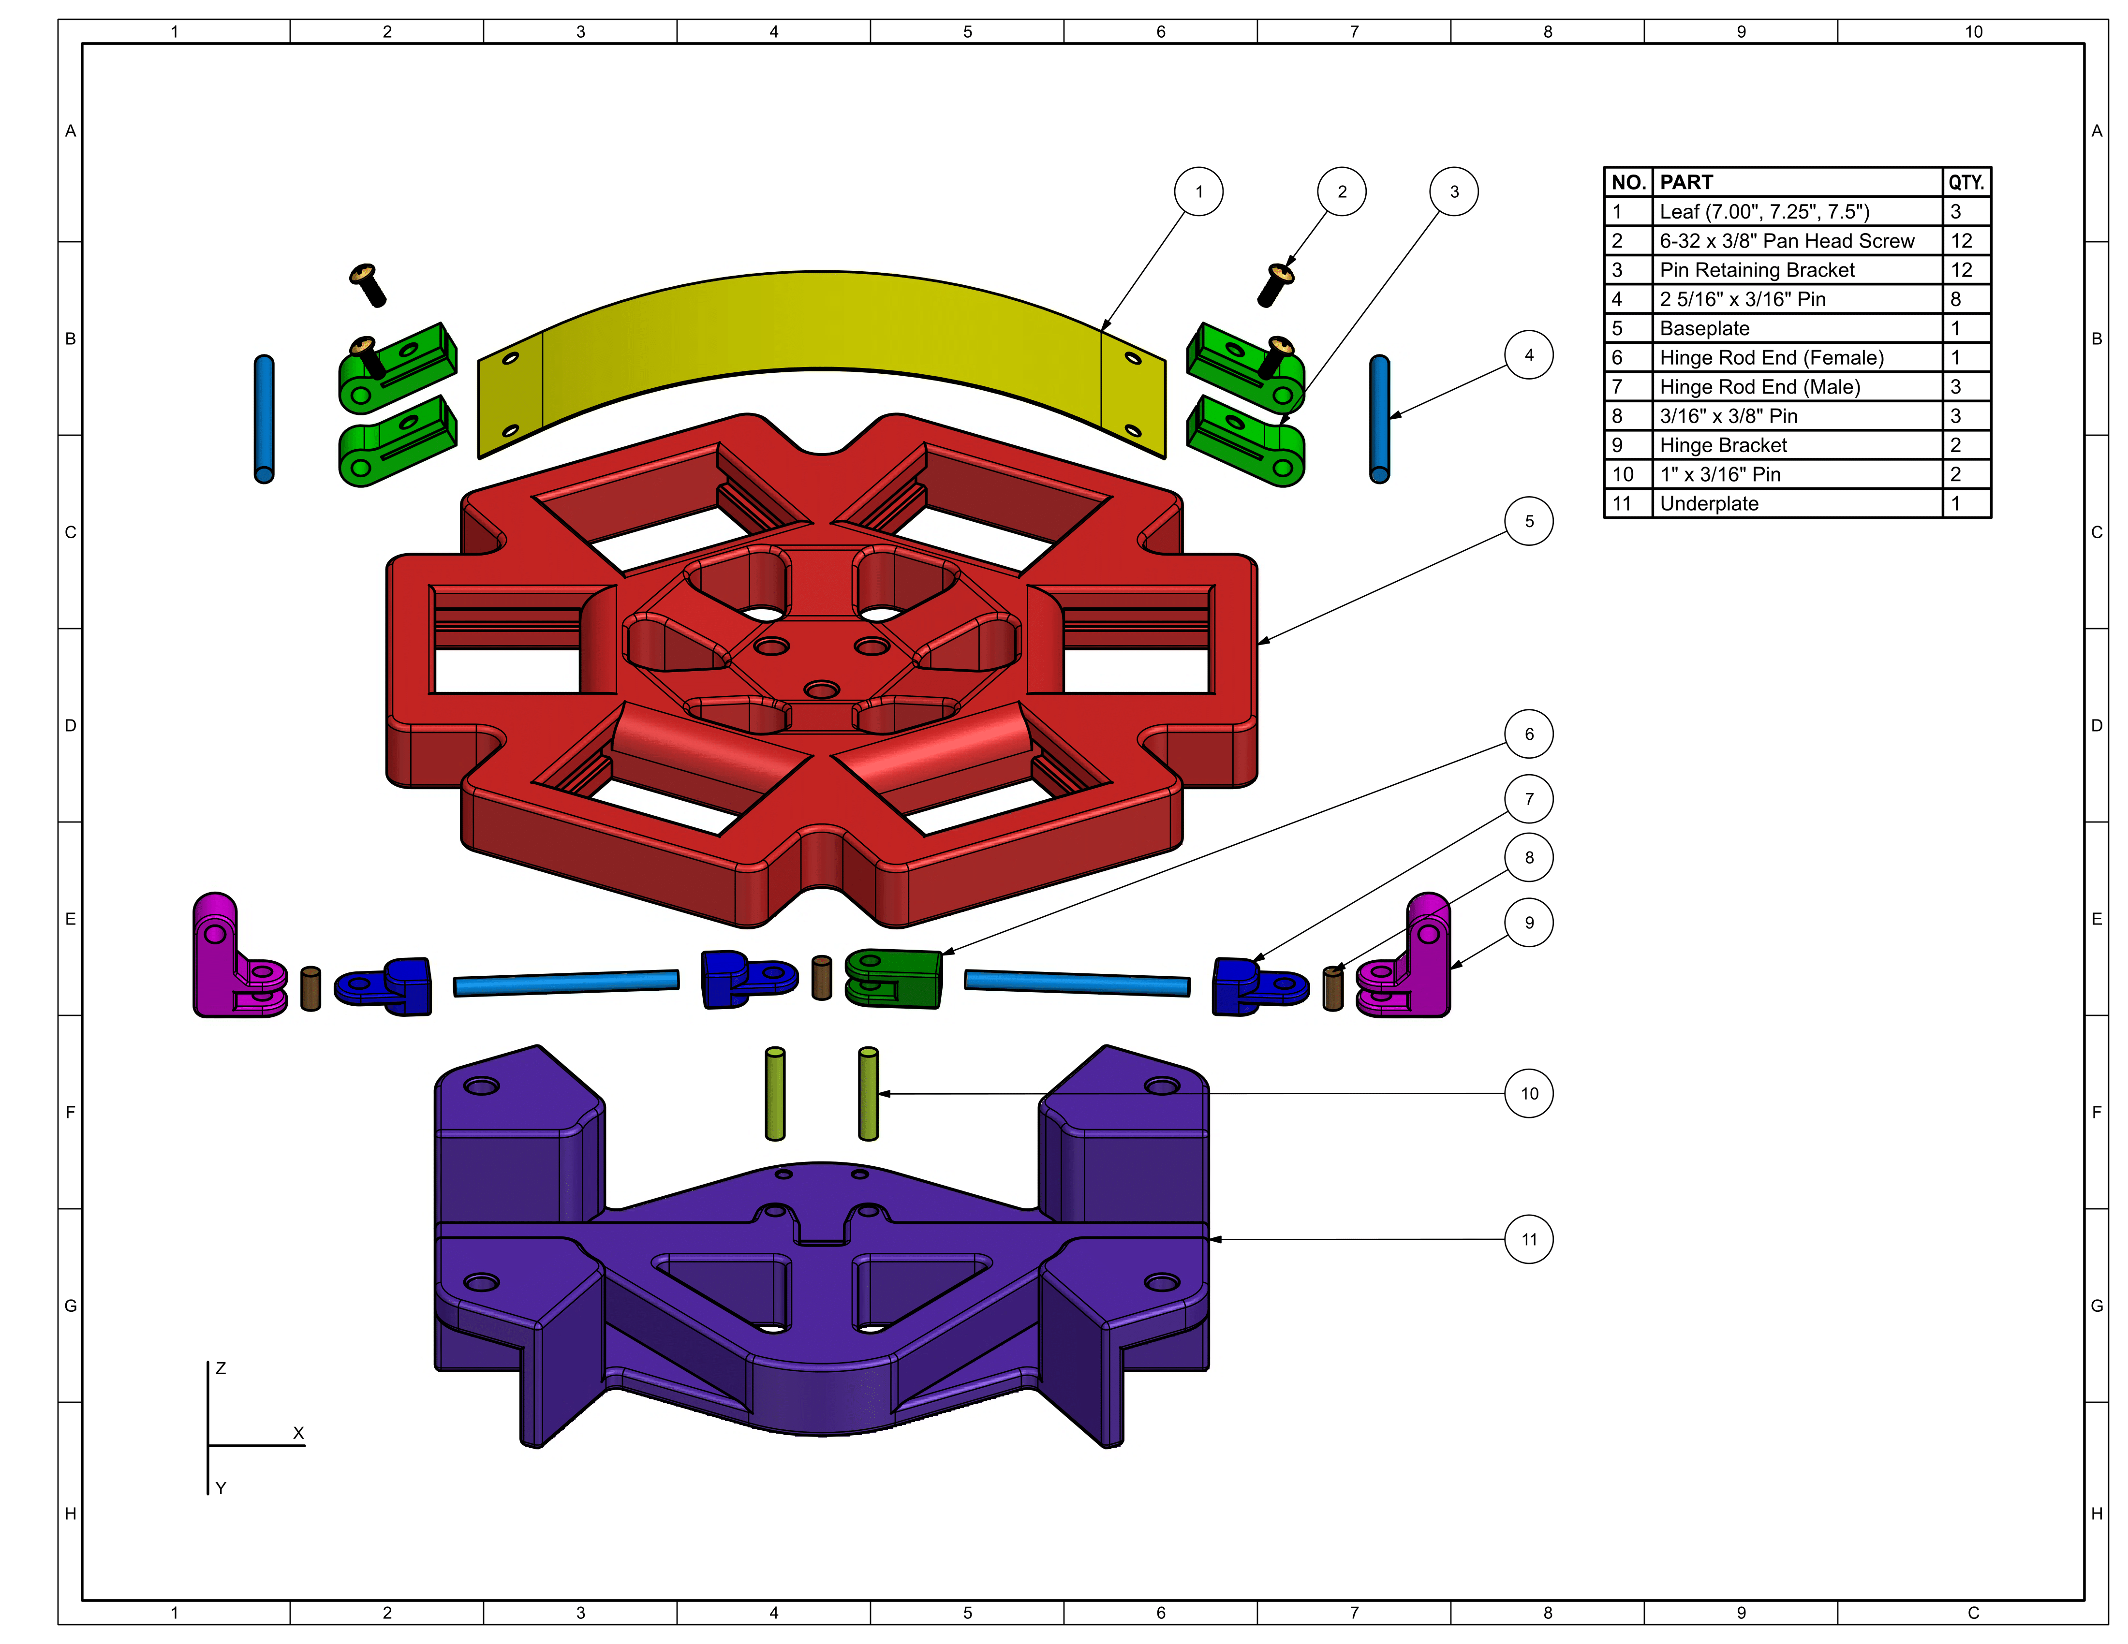
- Updated Budget
